SYSTEM DESIGN ASSIGNMENT
BessyV2
System Components & Architecture
A “Better Schoology” grades application built on a three-tier, database-backed system.

Prepared by Taehong Kim
Course [ Course name / number ]
Instructor [ Instructor name ]
Assignment Major system components + architecture diagram
Date September 12, 2026

Deliverables: (a) this component document and (b) the system architecture diagram in Section 2.

1. Overview
BessyV2 is a cross-platform grades application — a rebuild of the “Bessy / Better Schoology” app — organized as a classic three-tier system:
- Client tier — the apps people use: a Flutter student app (Android / iOS), a caregiver / parent mode, and a separate internal admin console.
- Application / API tier — a hosted API that is the single access path to the backend, plus the services around it (authentication, background workers, push).
- Data tier — a PostgreSQL database that is the system of record, plus object storage and a cache.
Grade data is captured keyless on the device (screenshots + OCR, a saved HTML grade report, and the Schoology iCal feed — nothing is scraped or automated), then synced up to the API and stored in the database. Putting the data in a server database is what unlocks the features a single offline phone cannot provide: cross-device sync, grade-change notifications, caregiver access, and human support and administration.

What exists today vs. what this phase builds
The Flutter client, the grade engine, and the keyless import layer are already built (running today against on-device storage). The backend — API, database, authentication, notifications, and the admin console — is what this phase builds. Every component in this document and diagram is marked BUILT or TO BUILD.

The seam that keeps this affordable
The client already reads its data through one interface, GradeRepository. A network-backed implementation (SyncRepository) plugs in behind that same interface, so adding the backend does not require rewriting the UI or the grade math.

2. System Architecture Diagram
The diagram spans two pages: the data sources and client tier (Figure 1), and the application / API tier and data tier (Figure 2). Solid indigo = client tier, outlined = application tier, teal = data tier; green marks components that exist today and amber marks components to build this phase.
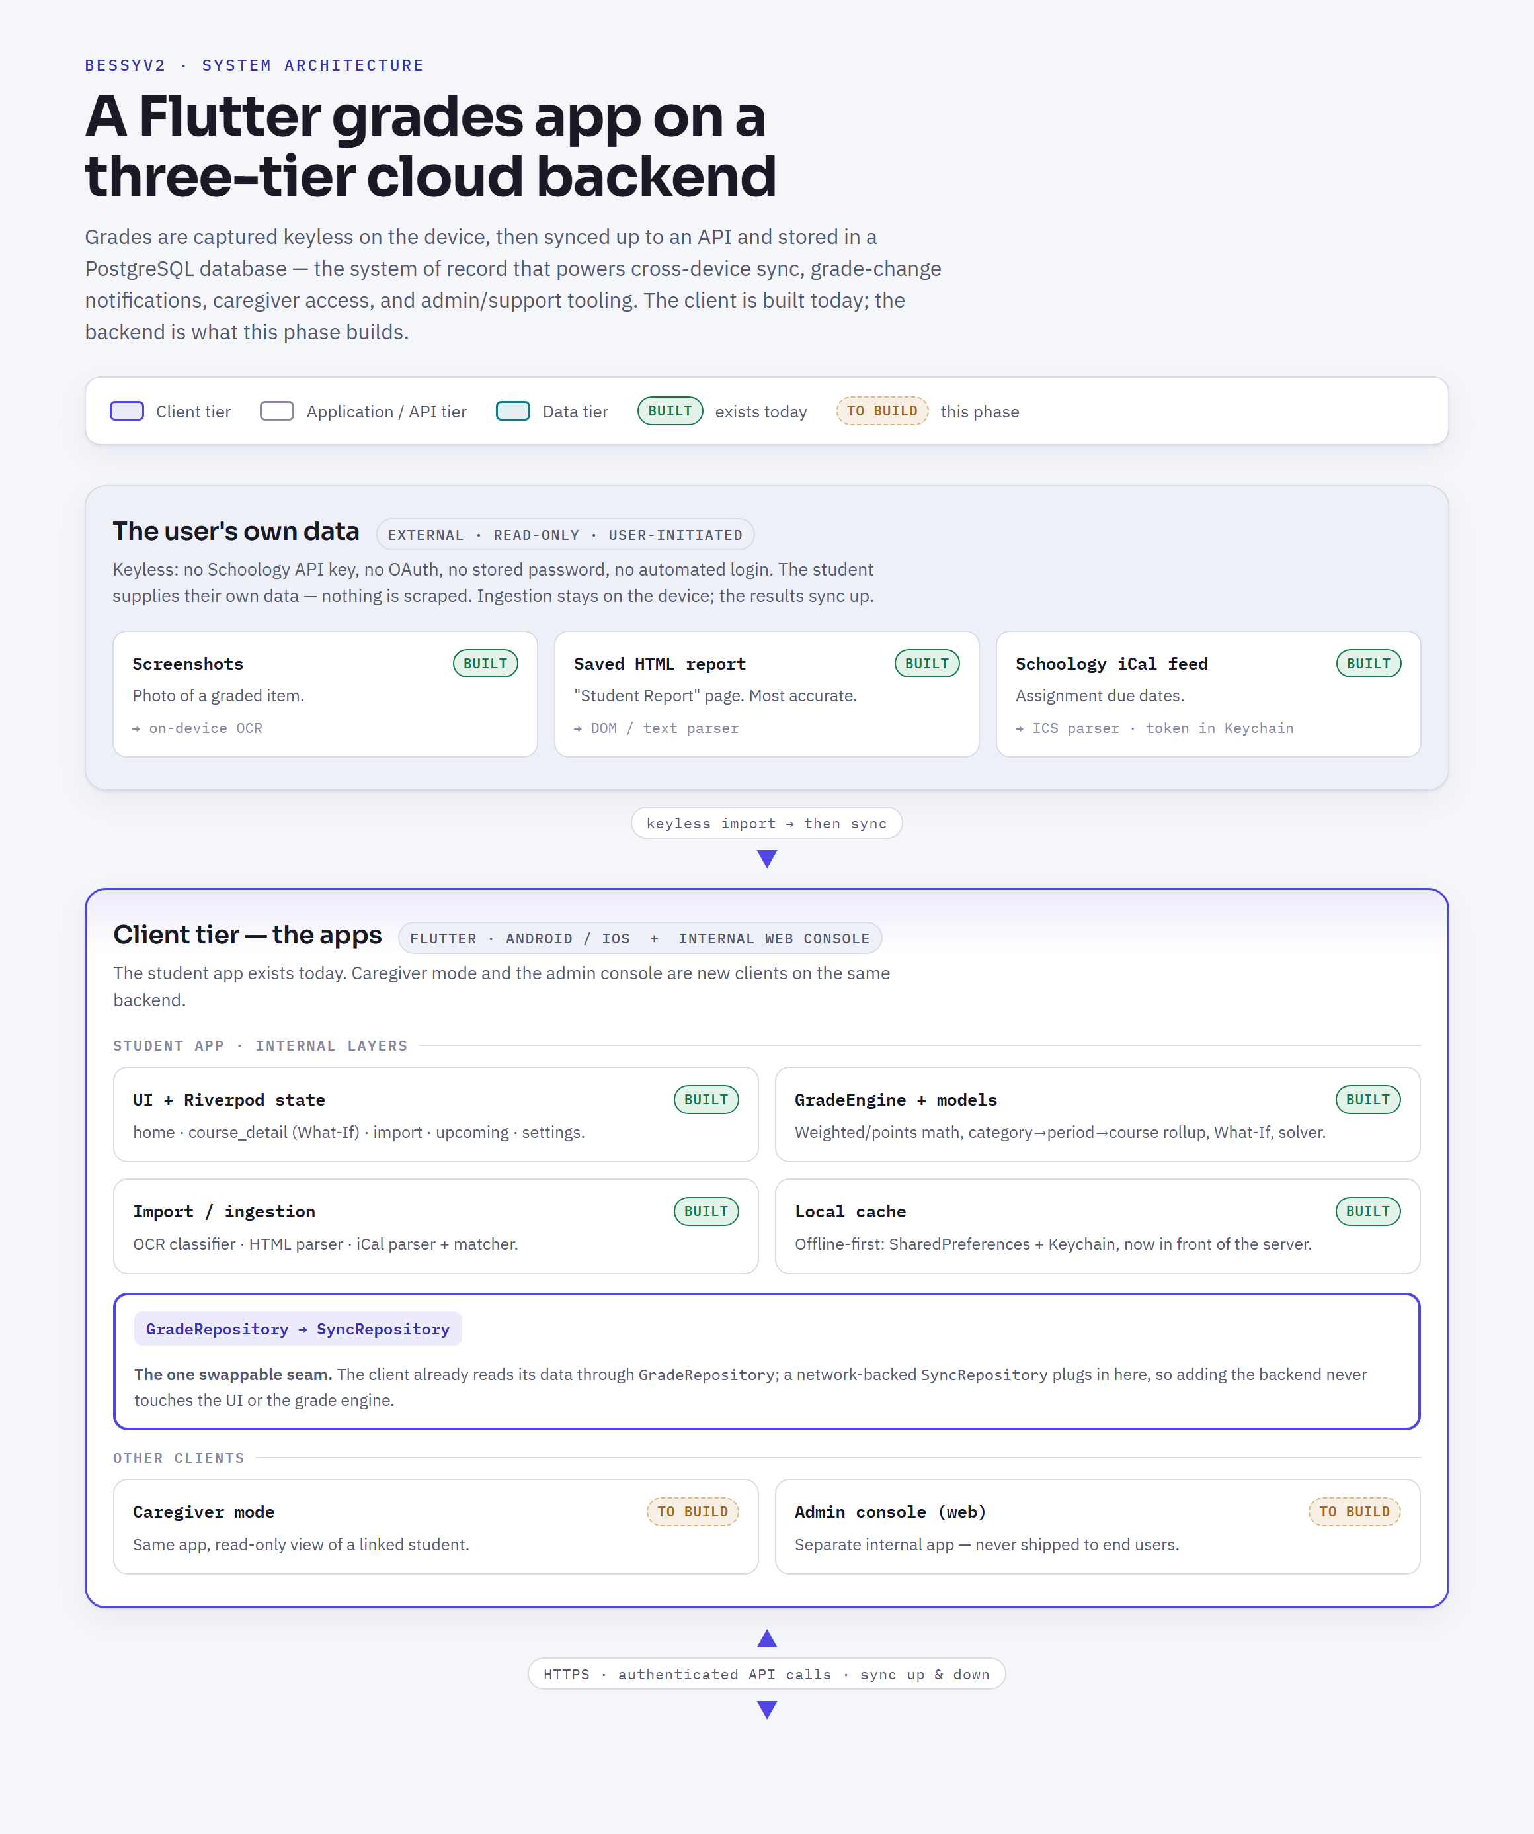
Figure 1 — Data sources and client tier

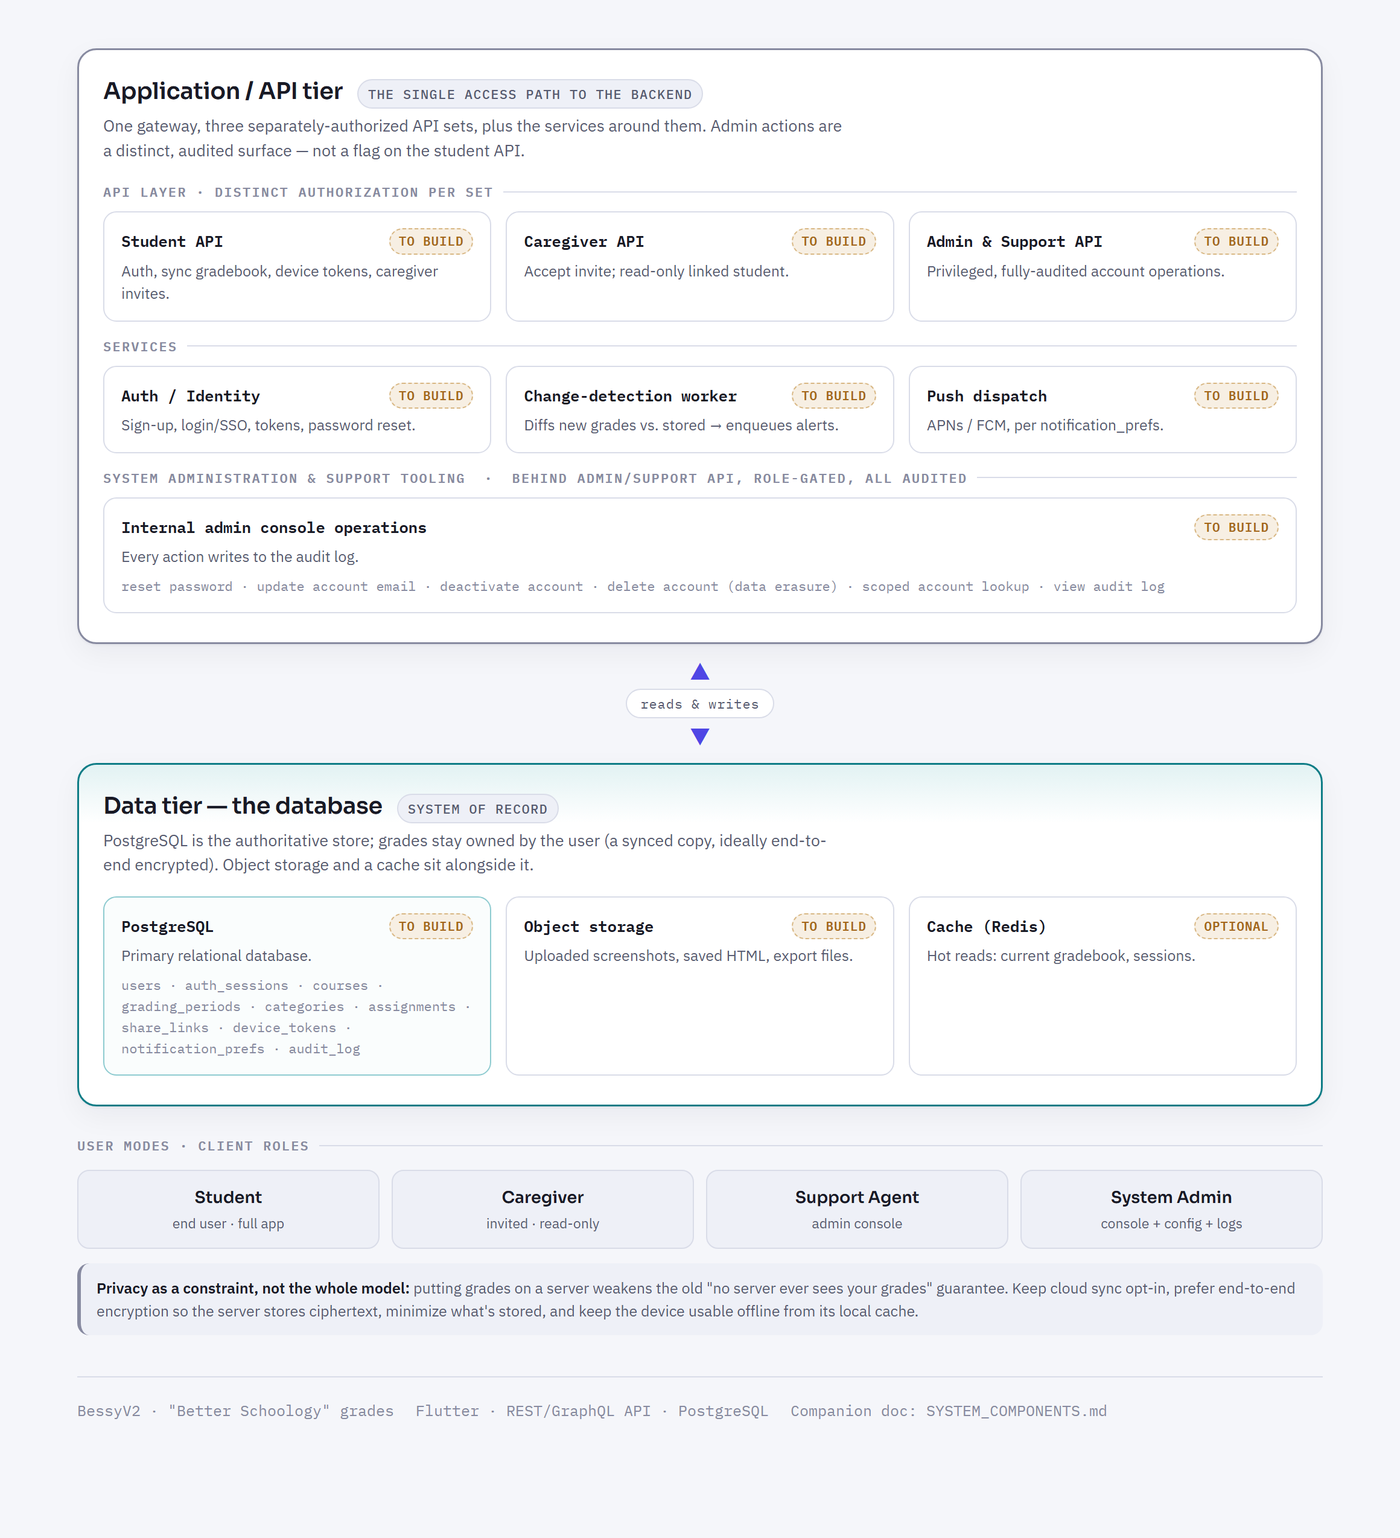
Figure 2 — Application / API tier and data tier

3. Component Inventory

3.1 Client tier — applications & user-facing modes
Student app BUILT — the existing Flutter app (Android / iOS; web for dev preview). It is internally layered:
Layer | Responsibility & key pieces
Presentation (UI) | home · course_detail (What-If) · import · upcoming · settings · onboarding.
State | Riverpod — gradebookProvider, whatIfProvider, upcomingProvider, themeModeProvider.
Domain / logic | GradeEngine (weighted + points-based math, category→period→course rollup, What-If, final-grade solver); models Course → GradingPeriod → Category → Assignment.
Import / ingestion | screenshot_classifier · html_report_parser · ical_parser + assignment_matcher.
Data access | The swappable seam: GradeRepository + a new SyncRepository (to build) that talks to the API.
Local cache | Offline-first store: SharedPreferences (JSON) + Keychain / Keystore — now a cache in front of the server, not the only copy.
Caregiver / parent mode TO BUILD — the same app in a read-only mode; a guardian the student invites can view the linked student’s grades and upcoming work.
Admin console TO BUILD — a separate internal web application for staff, never shipped to end users. This is where support agents and system admins operate on accounts (Section 5).

3.2 Application / API tier · to build
One gateway with three separately-authorized API sets, plus the services around them. Admin actions are a distinct, audited surface — not a flag on the student API.
- Student API — authentication, sync the gradebook up/down, register device push tokens, create and manage caregiver invites.
- Caregiver API — accept an invite; read-only access to a linked student’s grades.
- Admin / Support API — privileged, fully-audited account operations, on a separate surface with least privilege.
- Authentication / Identity service — sign-up and login (email + password and/or SSO), token issuance, sessions, password-reset flows.
- Change-detection & notification worker — a scheduled job that diffs the newest synced gradebook against the stored copy and enqueues notifications.
- Push dispatch — delivers alerts via APNs (iOS) and FCM (Android), respecting each user’s notification preferences.

3.3 Data tier — the database · to build
A managed relational database (PostgreSQL) is the system of record. Grades stay owned by the user — the database holds a synced copy, ideally end-to-end encrypted. Core tables:
Table | Holds
users | Student + caregiver accounts (id, email, auth metadata, status: active / deactivated).
auth_sessions | Tokens, refresh, and device sessions.
courses | Synced course rows (owner = user): name, term, color.
grading_periods | Quarter / semester rows with weight and date range.
categories | Weighted category rows (formative / summative buckets).
assignments | Item name, due date, score (earned / max), ungraded flag.
share_links | Student ↔ caregiver relationships and scope.
device_tokens | APNs / FCM tokens per device, per user.
notification_prefs | What each user wants to be alerted about.
audit_log | Every admin / support action — actor, target, action, timestamp (append-only).
Object storage TO BUILD — larger blobs the database should not hold: uploaded screenshots, saved HTML reports, export files. Cache OPTIONAL — a Redis cache for hot reads (a student’s current gradebook, session lookups).

3.4 External data sources & ingestion · built
Keyless: no Schoology API key, no OAuth, no stored password, no automated login. The student supplies their own data; ingestion runs on the device and the results sync up.
- Screenshots → on-device OCR → line classifier → confirm/edit → import (primary mobile path).
- Saved Grade Report HTML page → parser → exact scores, categories, and weights (most accurate).
- Schoology iCal feed → parsed for assignment events → due dates for the “Upcoming” agenda.

4. User Modes
Student and Caregiver are the same student app in different modes; Support Agent and System Admin use the separate internal admin console.
Mode | Who | Can do
Student | Primary end user | Everything in the app + sync, notifications, invite a caregiver.
Caregiver / Parent | A guardian the student invites | Read-only view of the linked student.
Support Agent | Internal staff | Account maintenance on request (Section 5).
System Admin | Internal owner | Everything Support can do + manage agents, system config, view audit logs.

5. System Administration & Support Tooling
The staff-facing operations required to safely run the product. All live behind the Admin / Support API, are gated by the Support / Admin roles, and write to the audit_log:
- Reset a password (or send a reset link) for a locked-out user.
- Update an account email address (fix a mistyped signup email).
- Deactivate an account (reversible) or delete it (permanent data erasure, on user request — GDPR / CCPA-style).
- Scoped account lookup to support a ticket — minimal fields, not open access to a student’s grades.
- View the audit log so every one of the above actions is attributable and reviewable.

6. Component Summary
Component | Tier | Status
Flutter student app (UI, state, engine, import, local cache) | Client | BUILT
Caregiver mode | Client | TO BUILD
Admin console (internal web app) | Client | TO BUILD
API layer — Student / Caregiver / Admin-Support sets | Application | TO BUILD
Authentication / Identity service | Application | TO BUILD
Change-detection worker + push dispatch (APNs / FCM) | Application | TO BUILD
PostgreSQL database (system of record) | Data | TO BUILD
Object storage (screenshots / HTML / exports) | Data | TO BUILD
Cache (Redis) | Data | OPTIONAL
Keyless import (screenshots + OCR, HTML, iCal) | Client | BUILT
System administration (reset pw, email, deactivate/delete, audit) | Application | TO BUILD

7. Suggested Build Order
- Database schema — model the tables in Section 3.3 (start with users, courses, grading_periods, categories, assignments).
- API + auth — Student API for sign-up / login and gradebook sync; the Authentication / Identity service.
- Wire the client — implement SyncRepository behind GradeRepository; the local store becomes an offline-first cache.
- Caregiver sharing — share_links, invite flow, Caregiver API + read-only mode.
- Notifications — change-detection worker, device_tokens, push dispatch, notification_prefs.
- Admin console — Admin / Support API + audit log + the Section 5 tooling.

8. Design Principles
- Three-tier, database-backed. The PostgreSQL database is the system of record; the API is the single access path; the clients are thin over it.
- One swappable data seam. The backend plugs in behind the GradeRepository interface the client already uses — the UI and grade engine are reused unchanged.
- Keyless ingestion stays client-side. No Schoology API key, no OAuth, no stored password, no automated login. The student supplies their own data; the app syncs it up.
- Privacy as a constraint, not the whole model. Cloud sync is opt-in; prefer end-to-end encryption (the server stores ciphertext) and data minimization. The device keeps a usable offline cache.
- Separate, audited admin surface. System administration is never a flag on the student app — it is a distinct API set, a distinct role, a distinct client, and every action is logged.

